# Cat Like Coding

[Reference](http://catlikecoding.com/)

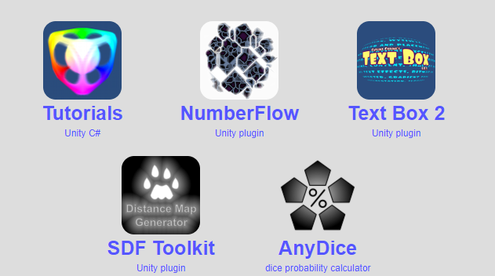

Tones of awesome staff

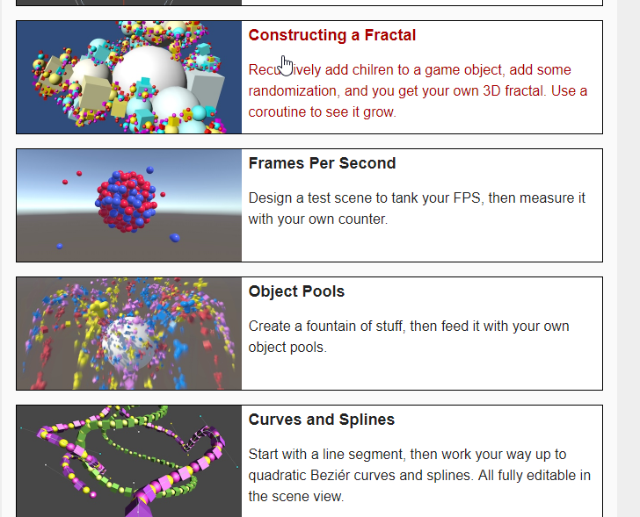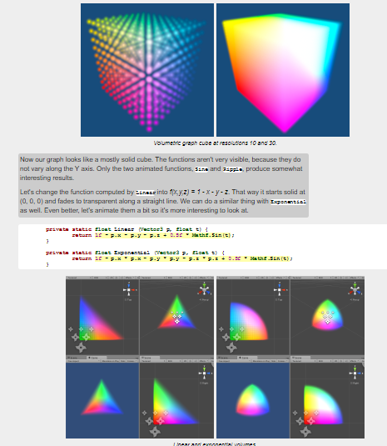

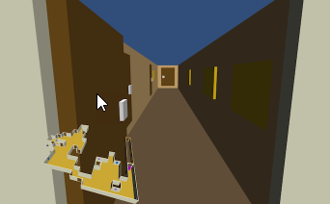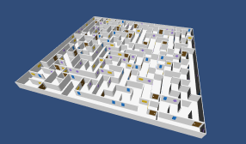

# Curves Besiles

<http://www.theappguruz.com/blog/bezier-curve-in-games>

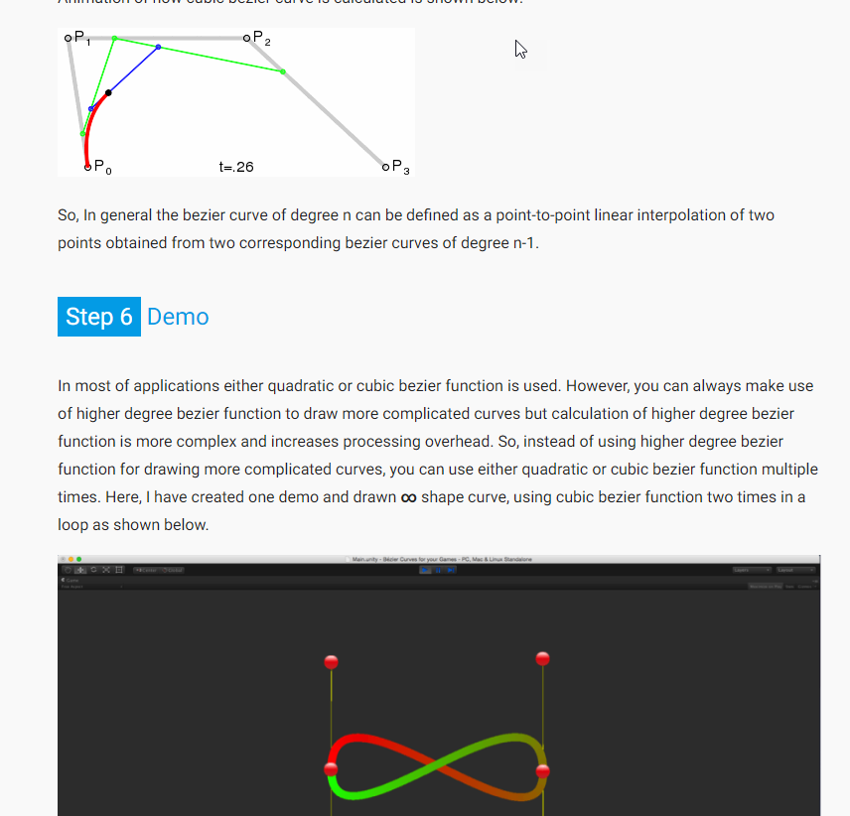

# Mesh Generation

<https://www.youtube.com/watch?v=o9RK6O2kOKo>

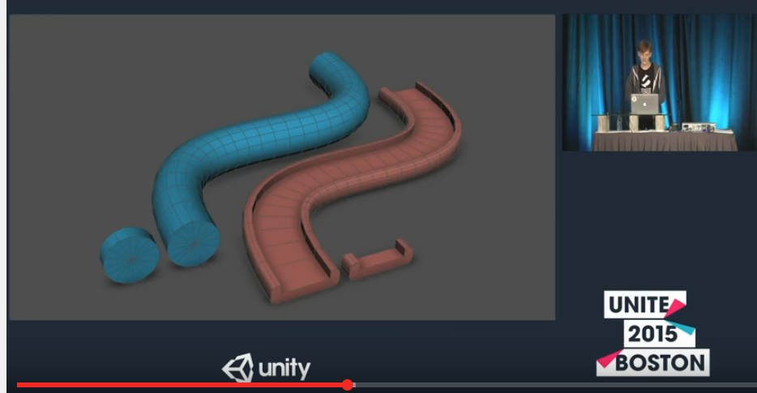

# Mesh extraction and perlin noise

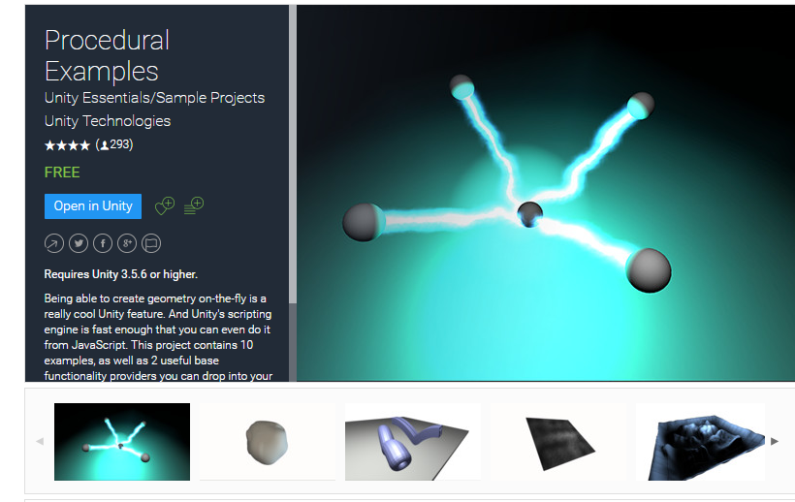

<https://www.assetstore.unity3d.com/en/#!/content/5141>

# Slicing Mesh

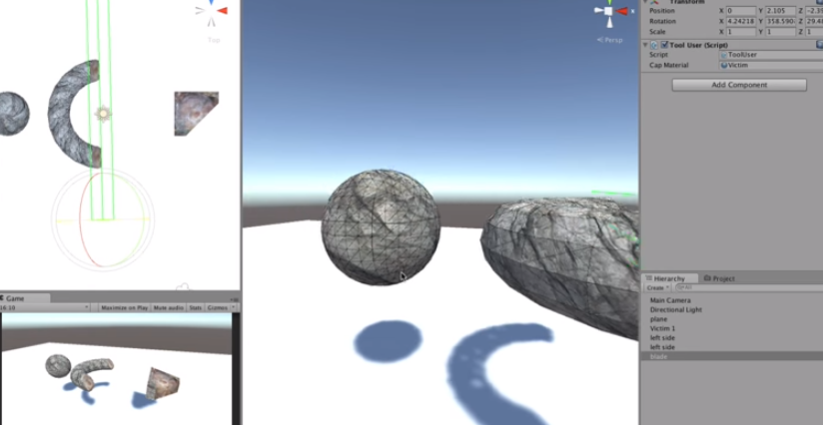

<https://www.youtube.com/watch?v=xgoUmrhXyYE>

# Mesh bool operations

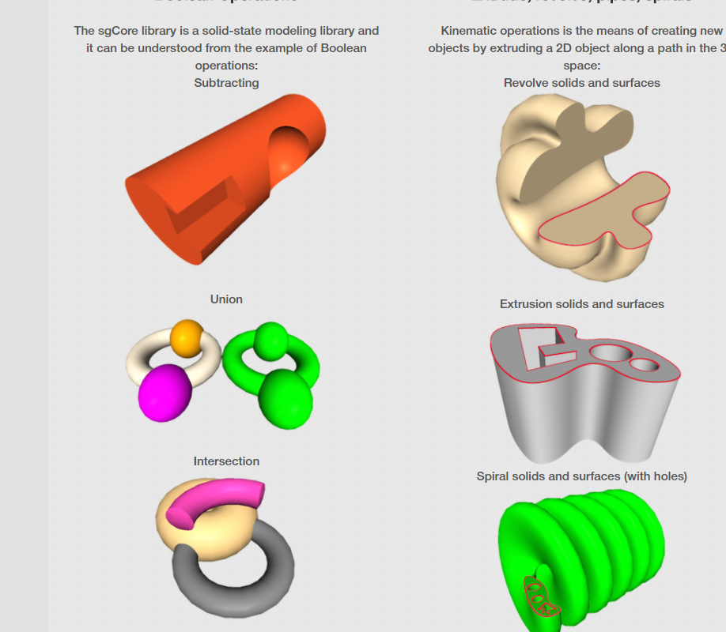

<http://www.geometros.com/index.html>

# Unity Machine learning

<https://blogs.unity3d.com/2017/12/11/using-machine-learning-agents-in-a-real-game-a-beginners-guide/>

s

# Making more performance

<https://www.cgcookie.com/articles/maximizing-your-unity-games-performance>

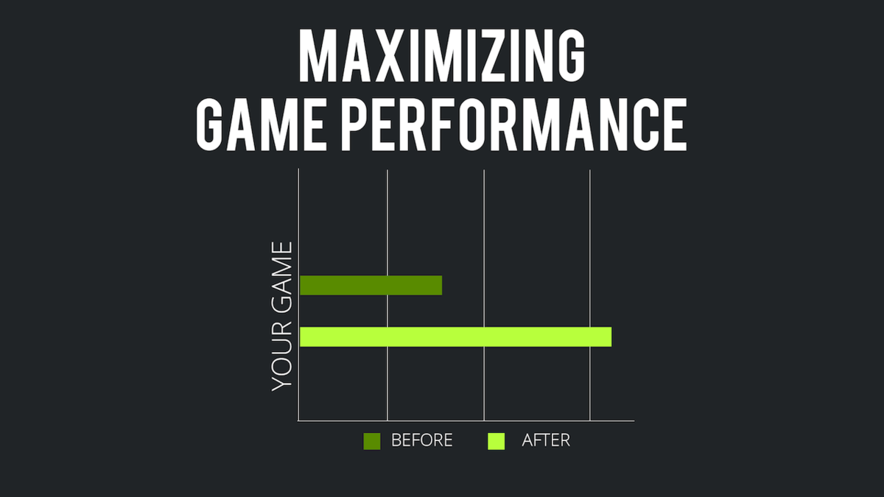

# Shaders

<https://lindenreid.wordpress.com/2017/12/30/ice-shader-in-unity/>